|  |
| --- |
|  |
| PSI4 Helper 1.0 |
| Application manual |
| **Marcel Patek 2018** |
|  |
|  |

Table of Contents

[1.1 What is PSI4 Helper? 2](#_Toc408757332)

[1.2 Recommended Reading 2](#_Toc408757333)

[1.3 Why PSI4 Helper? 2](#_Toc408757334)

[1.4 Requirements 3](#_Toc408757335)

[1.4.1 Java 7: 3](#_Toc408757336)

[1.4.2 ESS/NBO Program: 3](#_Toc408757337)

[1.4.3 PSI4 Helper Download: 4](#_Toc408757338)

[1.5 Installation 4](#_Toc408757339)

[2.0 Quick Overview 5](#_Toc408757340)

[2.1 Main window graphic interface 5](#_Toc408757341)

[2.2 Keylists tab 6](#_Toc408757342)

[2.3 ESS Input tab 7](#_Toc408757343)

[2.4 Batch input 8](#_Toc408757344)

[3.0 PSI4 Helper Usage – Details 10](#_Toc408757345)

[3.1 Settings 10](#_Toc408757346)

[3.2 Input Area 10](#_Toc408757347)

[3.3 Options Area 9](#_Toc408757348)

[3.4 Keylists 12](#_Toc408757349)

[3.5 ESS Input 13](#_Toc408757350)

[3.6 User Settings 14](#_Toc408757351)

[4.0 Updates 15](#_Toc408757352)

# 1.1 What is PSI4 Helper?

PSI4 Helper is java application which offers a simple way of generating:

1. Keylists and the corresponding keywords for standalone program PSI4 (processing of existing archive files (FILE47))
2. Keylists and the corresponding keywords for ESS-linked or "embedded" NBO modules
3. Input files with nbo keywords for two ESS/NBO programs, namely Gaussian09 and PC-GAMESS/Firefly

In general, PSI4 Helper assists with syntax of NBO keylists and keywords and formats them for input into standalone PSI4 program. It works with local NBO6 PSI4 executable to process .47 archive files. Generated .nbo files include results of NBO analysis. PSI4 Helper can also generate basic input files for electronic structure system (ESS) programs, which either included or linked NBO modules. In its specific adaptation, input files are formatted for Gaussian09 (G09) and PC-GAMESS/Firefly (FF).

PSI4 Helper assumes user’s familiarity with NBO programs developed by Frank Weinhold at University of Wisconsin. Specifically, this application makes use of standalone program PSI4 5.0W (Windows), PSI46 and NBO6 executable in the Windows distribution of NBO6 program.

C:\wamp\www\nbo\img\youtube.jpgFor details on NBO programs, visit NBO6 Website at <http://nbo6.chem.wisc.edu>

Introductory movie [is available at](http://youtu.be/GOVhjaYrfyQ)

# 1.2 Recommended Reading

In addition to the NBO6 website link, following resources are invaluable for a better understanding of chemical phenomena predicted by NBO analysis.

* [NBO6 manual](http://nbo6.chem.wisc.edu/nboman.pdf)
* F. Weinhold, “Natural bond orbital analysis: A critical overview of relationships to alternative bonding perspectives,” J. Comput. Chem. (2012).
* F. Weinhold and C. R. Landis, Valency and Bonding: A Natural Bond Orbital Donor-Acceptor Perspective (Cambridge U. Press, 2004), 760pp.
* F. Weinhold and C. R. Landis, Discovering Chemistry with Natural Bond Orbitals (Wiley-VCH, 2012), 319pp.

# 1.3 Why PSI4 Helper?

The main reason behind PSI4 Helper was to “script” repetitive tasks behind preparation of .47 archive files, running stand-alone PSI4 module, and consistently writing properly formatted ESS input files.

Another reason why PSI4 Helper came into existence was to assist teachers, students, and researchers with obtaining a variety of NBO results without detailed knowledge of syntax of NBO keywords and keylists.

# 1.4 Requirements

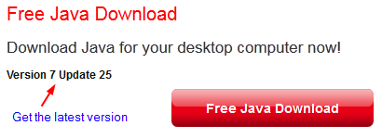1.4.1 Java 7: PSI4 Helper application is written in Java/JavaFX using free Sun’s JDK 1.8 and compiled with Java8. Make sure that you have the latest Java (JRE) installed on your computer. You can download the java installer jxpiinstall.exe form [here](http://java.com/en/download/index.jsp) or the latest platform-specific Java from [here](http://www.java.com/en/download/help/download_options.xml).

PSI4 Helper was developed and tested under Windows system (Win 10). Version 1.0 was also tested under Linux OS (Ubuntu/Mint 18) and was found functioning. If an error message appears upon the launch of PSI4 Helper, first and the most successful remedy is to (re)install the latest version of Java.

## Couldn't locate crtXXX.o in default library search paths.

Sudo apt-get install gcc; chesk as gcc-6 --version

Sudo apt-get install g++

bash Psi4conda-latest-py35-Linux-x86\_64.sh -b -p $HOME/psi4

export PATH=/home/mp/psi4/bin:$PATH

export PSI\_SCRATCH=/home/mp/psi\_scratch

1.4.2 ESS/NBO Program: to fully utilize all features of PSI4 Helper, Gaussian09 (G09W) or PC-GAMESS/Firefly is recommended for direct interaction with NBO routines. Windows version of G09 is based on the older nbo3.1 code. Since the revision D.01, G09W can now link with standalone NBO6 binaries via gaunbo6.bat batch script included in the NBO6 package ([available from NBO6 website](https://charge.wisc.edu/chemistry/order_nbo6.asp)).

PC-GAMESS/Firefly (FF) is freely available *ab initio* and DFT computational chemistry program developed and maintained by Dr. Alex A. Granovsky at Lomonosov Moscow State University (MSU). It can be downloaded [from here](http://classic.chem.msu.su/gran/gamess/index.html). To enable NBO analysis in FF, you need to purchase NBO ID and password from [NBO6 website](https://charge.wisc.edu/chemistry/order_nbo6.asp).

While ESS, NBO6, and Firefly binaries can be installed at any partition/directory on your system, recommended directories are:

c:\G09W

c:\nbo6w

c:\Firefly

1.4.3 PSI4 Helper Download: download zip file containing all required files and manual from [www.marcelpatek.com/nbo/nbo.html](file:///F:\Webpage\Blogger\Java_script\NBO%20Helper\www.marcelpatek.com\nbo\nbo.html) See section 1.5 for installation instructions.

# 1.5 Installation

PSI4 Helper is self-contained application. It can be run from any file folder on PC hard drive or optionally from USB drive. PSI4Helper.zip archive contains the following files:

* PSI4Helper.jar [main java application]
* geom.properties, coulomb.properties, stereoel.properties, sterics.properties, none.properties, set1.properties, set2.properties, set3.properties [presets of NBO keywords for different types of analysis]
* jvPSI4.bat [modified batch file to run nbo6ix.exe binary]
* PSI4Helper\_man.pdf [manual for this application]
* README.txt

Install

1. Unzip downloaded PSI4Helper.zip file and move its content into any directory on your system. Recommended place is c:\nbo\PSI4Helper
2. Move jvPSI4.bat into nbo6w directory (c:\nbo6w\jvPSI4.bat) [optional]\*
3. 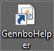Create shortcut of PSI4 Helper to your Desktop (right-mouse click the file -> Send to -> Desktop (create shortcut)
4. Double-click the shortcut icon to run the application
5. To install nbo6 binaries and supporting files, follow instructions in the NBO6 package [optional]\*

\* Installation of NBO6w package from [TCI/NBO Software](https://charge.wisc.edu/chemistry/order_nbo6.asp)  is optional.

# F:\Webpage\Blogger\Java_script\NBO Helper\imgs\main_basic1a.png2.0 Quick Overview

## 2.1 Main window graphic interface

PSI4 Helper graphical interface consists of three main areas:

1. File input (top, red)
2. Options (middle, blue)
3. Output (bottom, red)

Load .47 archive file (generated by ESS program) by clicking “1. Browse Dir” button next to (**1**). To import preset keywords with loaded .47 file, choose requested preset from the pull-down menu next to “Load NBO settings”.

**Options** are is subdivided into three tabs for different tasks. Basic Keywords are selected by checking the corresponding check boxes and other options from threshold values, atom lists, and pull-down menus.

After pressing “3. Create/Append input” button (**4**), checked keywords with options will appear in the output text area (**3**). By clicking “Write \*.47” button (**5**), nbo keywords are inserted to the $NBO … $END line in .47 file.

Providing that you have specified path to nbo6w directory in File input area (**1)** at “2. Load Dir”, **2**, by clicking “Run PSI46” (**6**) all job parameters will be passed to PSI46.exe and processed in a usual manner. Once the job is finished, confirmation window will appear and newly created files will be moved to the original directory of .47 file (**1**). Open that directory and inspect created .nbo file. Launching the PSI46 through the button (**6)** works only under Windows OS.

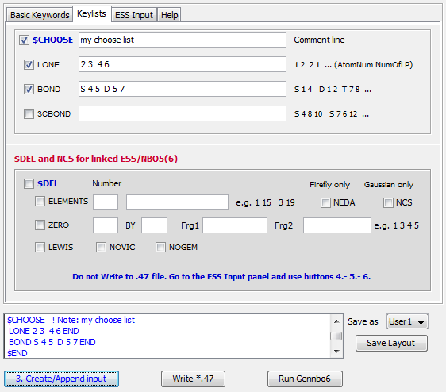2.2 Keylists tab allows for selection of more advanced lists/keywords, namely ***$CHOOSE*** and ***$DEL*** keylists. There are two input areas, use of which depends whether nbo modules are part of the ESS program (or linked to it) or whether one would be using only PSI4 module. In the latter case, only ***$CHOOSE*** keylists should be used. Again, check boxes need to be selected and list of atom/bond descriptors provided into text fields on the right. Mouse-over position of cursor will display hints for proper formatting..

In the next step, proceed as before - by clicking “3. Create/Append input”, “Write \*.47”, and “Run PSI46”.

With access to the NBO program compiled directly into ESS (FF) or linked to ESS (G09W), one can run interactive analysis using keylist **$DEL**. Choosing options is the same as for **$CHOOSE** keylist with one **important exception.** After selecting NBO options, proceed to the next tab (ESS Input) to setup ESS-specific input file. Press buttons 4.-5.-6. in sequence. Do not use “Write \*.47” and “Run PSI46” buttons.

Since ***NEDA*** and ***NCS*** options also require interaction of NBO modules with ESS, those two options were placed in this area as well. Note that ***NEDA*** is only implemented in Firefly and ***NCS*** keyword works only in G09.

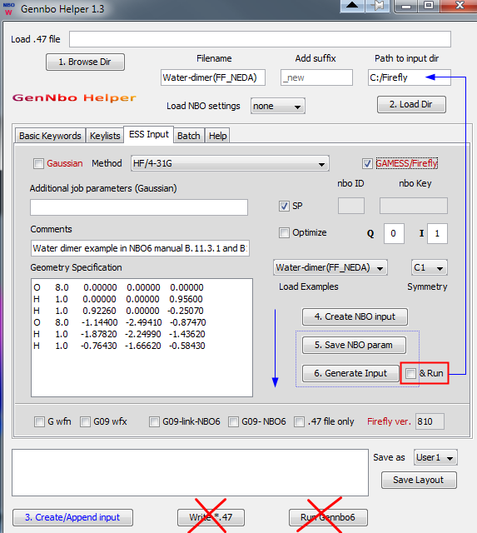2.3 ESS Input tab is the place where basic ESS input files can be setup and created. PSI4 Helper currently supports only G03/09w and Firefly. Pull-down menus and check boxes offer selection of computational method, examples of molecular geometries, symmetry, and other options to be added into input files. After all the necessary parameters are entered, click on buttons **4.-5.-6.** “Create NBO input” button has the same function as button “3. Create/Append input”. It populates the output area with NBO keywords. Should you use any of the “Load Nbo settings” methods, click buttons **5.-6.** only (blue dot rectangle). “Save NBO param” will copy all keylists and keywords from the nbo output area and “Generate Input” button will create new .inp or .gjf file for use in FF or G09, respectively. Checking the new checkbox “Run” and clicking button 6. will generate windows batch file “gausstun.bat” in the directory set by clicking button 2. If Gaussian program is installed in C:/G09W, the job will start immediately. Similarly, Firefly/GAMESS option creates the corresponding \*.ini files together with \*.bat file to start calculations (Windows only). Generation of **.bat** files was added for a greater convenience of Windows users and won’t work on other systems. All options except of running Gaussian (&Run) work also under Linux OS.

*Since .bat file for Firefly jobs requires the latest fireflyxxx.exe file, enter the current version of Firefly into the box “Firefly ver.” (no decimal points, just three numbers).*

2.4 Batch input tab allows PSI4 processing of multiple .47 files from one directory. Running a batch of .47 files is independent of other settings in the app.

Prerequisites:

In order to process .47 files by PSI46 modules, a helper ***jvPSI4.bat*** file has to be present in the main NBO6 directory (here c:/nbo6w). The file is part of the download. Since it is Windows file, the Batch processing is limited to Window users.

1. First set the NBO6 (PSI4) directory using the button “2. Load Dir”.
2. Load .47 files by clicking the “Load Files” button (**1.**) and by control-selecting multiple files in that directory. Selected files will appear in the Batch list area.
3. Write NBO keywords and lists into $NBO $END section of the .47 files. By clicking the “Write Batch” button, keywords in the **NBO keyword and keylist area** will be inserted into all .47 files. Successful insertion of keywords will be indicated in the **Notification area** at the bottom of the window.

Optionally, if .47 files already have $NBO section populated, skip the “Write Batch” step. Clicking the “Write Batch” button (**2.**) with no keywords in the **Keyword and keylist area**, default keyword **PRINT=0** will be used.

1. 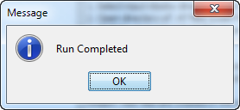By pressing “Run batch” button (**3.**) a loop feeding each .47 file into PSI4 modules will be launched. Progress monitor bar will indicate status of the processing and current file being process by PSI4 modules will be shown in the text field left of the progress bar. Upon completion, a message window will pop up.

**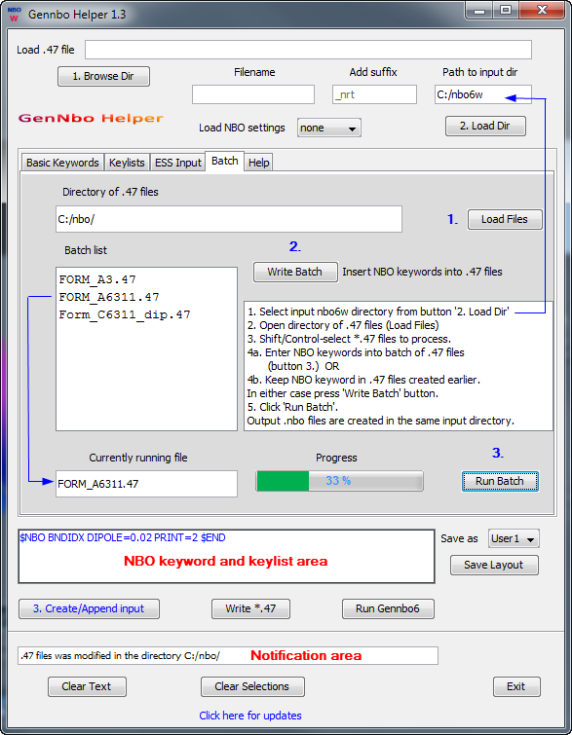**

Batch writing except running the PSI4 programs from this tab (**3.**) will also work under Linux OS.

# 3.0 PSI4 Helper Usage – Details

## 3.1 Settings

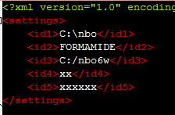After the first run, PSI4 Helper will create file **nbo\_def.xml**, which keeps last entered path to .47 file, filename and path to nbo6w directory on your computer. Also, if you have entered Firefly NBO ID and NBO password into the corresponding fields on ESS Input tab, both values will be stored and retrieved at each run. Path to nbo\_def.xml file is the same as the path of main PSI4Helper.jar file (e.g., c:\nbo\PSI4Helper). This file can be easily edited and individual entries changed manually. Characters xx and xxxxxx are substituted for the Firefly ID and password.

Recommended folders for discussed ESS/NBO programs are:

* c:\G09W
* c:\nbo6w
* c:\Firefly
* c:\nbo\PSI4Helper

Avoid spaces in directory filenames

## 3.2 Input Area

After opening the application, click on “1. Browse Dir” button and browse for .47 file on your computer. This file was created earlier by running ESS program (e.g. G09W, FF) with specific instructions in the input card. Such file can be also generated from the ESS Input tab described later.

By loading .47 file, path and filename are parsed out and entered into the corresponding text fields. “Add suffix” entry is optional (default is \_new) and it allows distinguishing between original and modified .47 files.

“2. Load Dir” button lets you browse for NBO6 standalone program directory (typically, c:\nbo6w) or for default directory from which ESS programs takes the input files (typically, c:\FIREFLY, c:\G09W\Scratch).

Path and filename can be also entered directly into text fields or the nbo\_def.xml file.

Once files and directories are selected or manually entered, proceed to Options area or use the “Load NBO settings” pull-down menu in the Input area to fast-load preset nbo keywords.

## 3.3 Options Area

***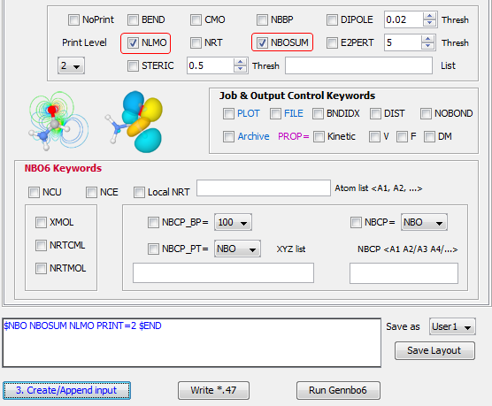***Options area contains several groups of keyword check boxes and optional entries. Default level for Printing is 2 and it can be changed to any available level including 0. Alternatively, checking ***NoPrint*** box will remove ***PRINT*** keyword from the nbo keyword list. ***Dipole***, ***E2Pert***, and ***Steric*** have optional settings for desired output level. In addition, ***Steric*** option can be extended with list of NLMOs in the following format: N1 N2/N3 N4 …..

Options area

In the middle part of Options is a group of control keywords. By selecting ***Plot*** or ***Archive*** keyword will always set ***FILE*** keyword as well.

Hovering mouse over any field will display tip on format or keyword.

The last area contains new keywords from NBO6 program, which are not available in previous versions. For Natural Bond Critical Point Electron Density (***NBCP\_PT***), one can select the basis at which density will be evaluated (NBO, NLMO, MO) as well as specific coordinates at which the density will be calculated.

Similarly, Natural Bond Critical Point (***NBCP***) can be evaluated with different basis and between specific pairs of atoms (entered into text field below). After keywords and options are selected in the Options Area, click the “3. Create/Append input” button to create list of keywords. List will appear as a blue text in the Output area. Should you wish to modify or change any keyword, just type directly into the keyword list and **DO NOT** click “3. Create/Append input” button.

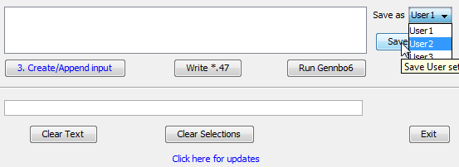If you wish to save your custom keyword list (or keylist with keywords), choose one of the three user settings in the pull-down menu on right (User1, User2, User3) and click “Save Layout”. Save setting can be loaded next time from “Load NBO settings” in the Input Area (3.2)

In the next step, write keywords into.47 archive file selected earlier (3.2) by clicking “Write\*.47” button.

Confirmation will appear in the text field at the bottom with the new filename and directory of modified .47 file.

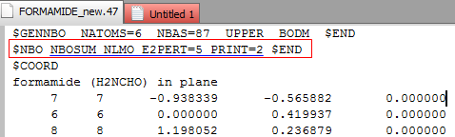

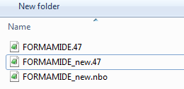

New file .47 will be written into directory selected earlier by “Load Dir” button (3.2). In this case, it is c:\nbo6w.

Clicking “Run PSI46” button will launch PSI46 executable from the standalone nbo6 program. When analysis is done, new files including \*.nbo will be created and moved into the original .47 file directory selected earlier by “1. Browse Dir” (3.2). Confirmation message will appear when run is complete. Alternatively, run PSI45W with modified file .47 as an input.

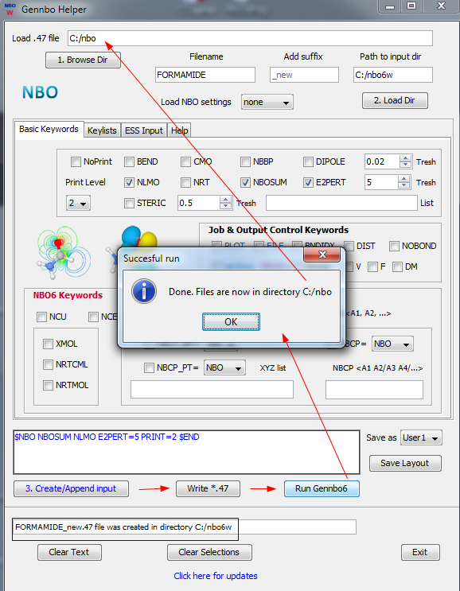

At any point, generated nbo list can be reset by “Clear Text” button and checkboxes unchecked by “Clear Selection” button.

## F:\Webpage\Blogger\Java_script\NBO Helper\imgs\key_choose.png3.4 Keylists

Keylists tab is for advanced settings when user requires more control over the specific elements or routines. **$CHOOSE** keylist can be used with standalone PSI45/6 programs while $DEL keylist is limited to either linked ESS-NBO modules or when NBO is directly compiled with ESS binaries.

**$CHOOSE** check box has to be checked for the list to appear in the nbo keylist. At least one of the keywords ***LONE,*** ***BOND***, ***3CBOND*** should be selected and atom information entered into the text fields next to each keyword. Format of list entries is indicated on the right and can be also reviewed by placing mouse cursor over the field. If format of keylist is incorrect, warning message will appear asking you to correct formatting.

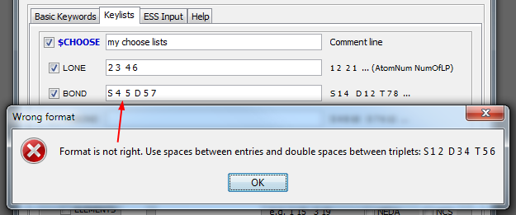Press “3. Create/Append input” button to populate the nbo keyword list. Optionally, save keylist with other nbo keywords to custom User settings 1-3.

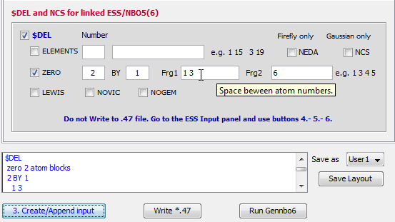

**$DEL** keylist follows similar logic. Check **$DEL** box and then one of the lists. While ***NEDA*** and ***NCS*** keywords are not necessarily parts of ***$DEL*** list, they were added into this group as they also require nbo modules being either internal or linked to ESS program. Press “3. Create/Append input” button to populate the nbo keyword list.

If either ***$CHOOSE*** or ***$DEL*** keylist requires more elaborate setup, just write those keylists directly into the nbo output text field and **DO NOT** click “3. Create/Append input” button.

## 3.5 ESS Input

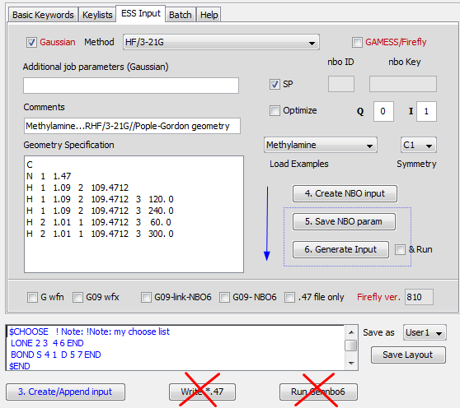ESS input tab was added to provide access to properly formatted input files for two ESS programs, G09w and Firefly. Gaussian check box is selected by default with explicit single point (energy) calculation. You can add comments and for G09w also additional keywords into the input card. Enter geometry (paste XYZ or z-matrix coordinates), select method, enter charge and multiplicity, and go back to Basic or Keylists tabs to select requested nbo keywords. Change the “Path to input dir” to desired location of the input file (**2**).

Similarly, for the Firefly, check the GAMESS/Firefly box, enter NBO ID and keyword, and select charge and multiplicity, symmetry, and enter geometry.

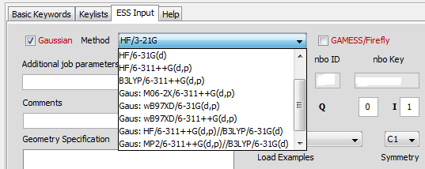Click “4. Create NBO input” button to generate nbo list and then proceed to buttons (**5**) and (**6**). The corresponding .inp or .gjf file will be created in the directory selected earlier in 3.2.

Several preset methods (theory, level for energy/geometry) are available from pull-down menu located between Gaussian and GAMESS/FF check boxes. Due to specifics of each ESS program, some methods have labels (Gaus:, Gam: ) to be matched with the corresponding ESS program.

In order to follow examples from the excellent book of ***F. Weinhold and C. R. Landis, Discovering Chemistry with Natural Bond Orbitals (Wiley-VCH, 2012),*** several geometries of book examples were added into the pull-down menu in the middle of ESS input panel.

Use z-mat geometries with Firefly.

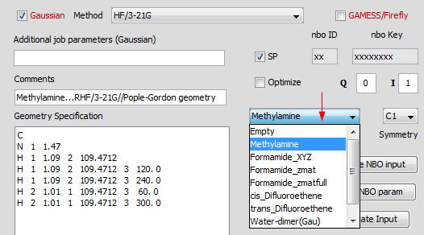

At the bottom of ESS Input tab, there are several checkboxes which will be discussed next.

Refer to section 2.3. for details on running Gaussian and Firefly. Initial setup files are generated including .bat files to start the job (Windows users only).

G wfn and G09 wfx: append --link1-- option in G09 to write AIM wavefunction file .wfx and its extended version .wfx. Both files can be used in AIM analysis by [AIMALL program](http://aim.tkgristmill.com/).

G09-link-NBO6: adds keywords “***EXTERNAL***” and “pop=nbo6read” into G09w route card to link NBO6 Windows binaries to G09w (revision D.01).

G09-NBO: adds NBO6 specific keywords (pop=nbo6read) into the route card of G09w, which had NBO6 compiled together with G09w binaries.

.47 file only: instructs ESS to generate .47 archive file for later analysis by PSI45/6. This is equivalent to NBO keywords ***ARCHIVE FILE***=xxx.



## **3.**6 User Settings

In the Input and Output areas, there are two pull-down menus with nbo keyword presets and user settings. NBO keywords that are generated by user (or just typed in) can be saved in three different User settings. The corresponding .properties files are plain xml formatted text files placed in the main application directory. Feel free to modify them. Loading those property files will override any keywords in the output area. Presets do not include ESS settings.

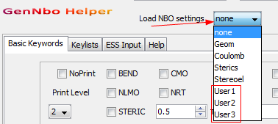Empty property file (none) is loaded by default.

String of editable nbo keywords is shown in the red rectangle for a particular example of geom.properties.

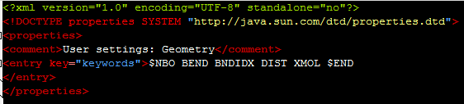

# 4.0 Updates

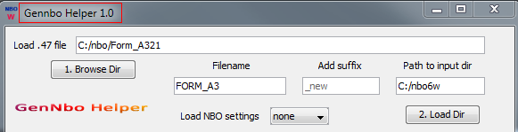To check for the current version of PSI4 Helper, locate the version at the top-left of the main application window. In this case, it is version 1.0

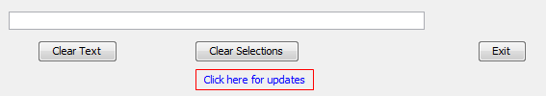To get the latest version, click the link at the bottom of the main application or visit [NBO Scripts and Handy Applications](http://www.marcelpatek.com/nbo/nbo.html) webpage. Download the latest version, and replace files in the original directory (c:/nbo/PSI4Helper).